V. System



DOJO 8 COWORKING SPACES

Timekeeping System

USERS MANUAL

1. **Description of the System**

The system is a simple timekeeping system used by Dojo 8 CoWorking Spaces. Its leading purpose is to record the time in and time out of customers. These will then store as a record in the system’s logbook which can be accessed and viewed conveniently.

**2.0 Getting Started**

2.1 Login

When application is launched, a login page first displays. User must login before proceeding and accessing the main page. The user is required to enter their login details in their respective fields, specifically the Staff ID and Password text fields.

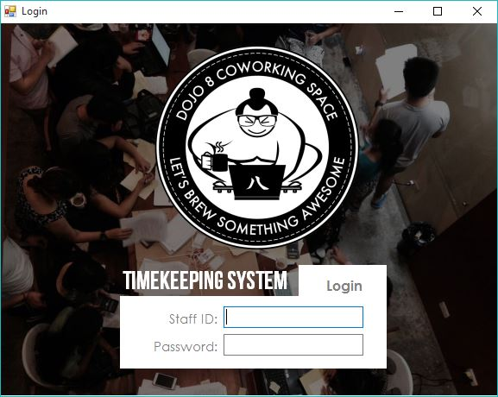

*Figure 1.* Staff ID text field – where the user can input their Staff ID

*Figure 2.* Password text field – where the user can input their password

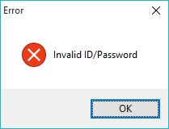If either the submitted Staff ID or Password is invalid, an error message notifies the user. The user will have to re-enter the correct Staff ID or Password in order to proceed.

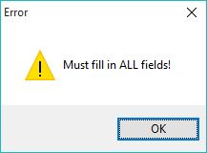

If the user fails to provide sufficient details and submits a blank field in either the Staff ID or Password field, an error message notifies the user. The user must provide all details in order to proceed.

2.2 Main Page

Once the user has successfully logged in, they will be redirected to the main page. The main page contains a variety of functions the user may utilize. The main page displays on overview of the three main modules: customer management, packages and promos management, and timekeeping. The user may navigate through these different modules.

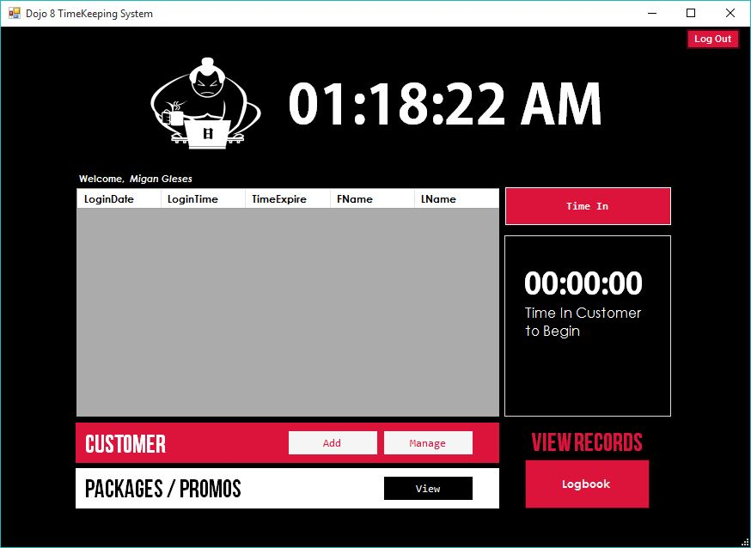

*Figure 1.* Timetable – displays all customers currently timed in and their information

*Figure 2.* Manage Customers Section – contains buttons, such as add and manage, for customer-related functions

*Figure 3.* Manage Packages and Promos Section - contains buttons, such as add (applied only to administrators) and view, for package-related and promo-related functions

*Figure 4.* Time In Button – displays a window with a list of eligible customers the user may time in

*Figure 5.* Customer Information – shows time remaining of customer who is timed in

*Figure 6.* Logbook Button – opens a window showing the logbook and its records

*Figure 7.* Log Out Button – ends a user’s session and logs out

1. **System Functions**

3.1 Manage Customers

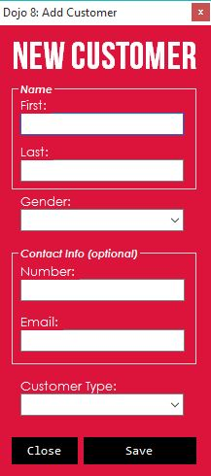Once the user clicks on the new button within the manage customers section in the main page, this will prompt an add customer window. The user must fill up the required fields, such as first and last name, gender, and customer type.

*Figure 1.* User Information Fields – contains data input by user for the new customer record

*Figure 2.* Close Button – closes the add customer window

*Figure 3.* Save Button – saves the new customer information input by user and submits to the customer records

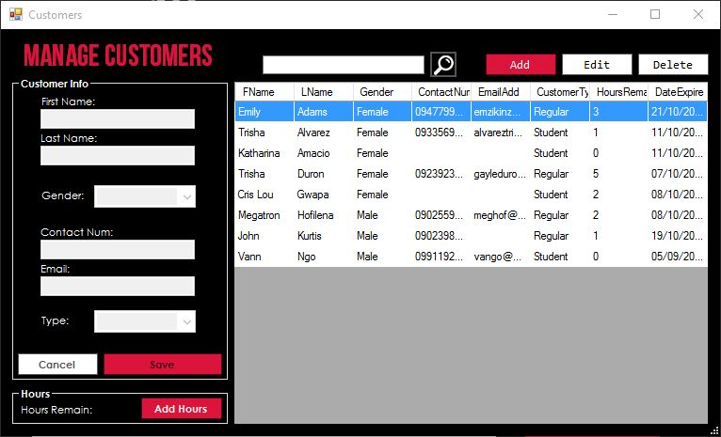

The user may view all customer records by clicking the Manage button found under the customers section in the main page. This window contains all records of customers the user wishes to view. This enables the user to easily manage each customer.

*Figure 1.* Search Bar – allows the user to search through records by first or last name

*Figure 2*. Function Buttons – user may add new customer, edit or delete selected customer

*Figure 3.* Add Hours Button – when a customer wishes to add more hours, the user may add the number of hours based on the package purchased

*Figure 4.* Customer Information Section – contains all information and data pertaining to the selected customer

*Figure 5.* Table – contains a list of all customers and their information

When a customer wishes to purchase more hours, the user may click the Add Hours button. This prompts a window with a list of packages the customer may avail and purchase.

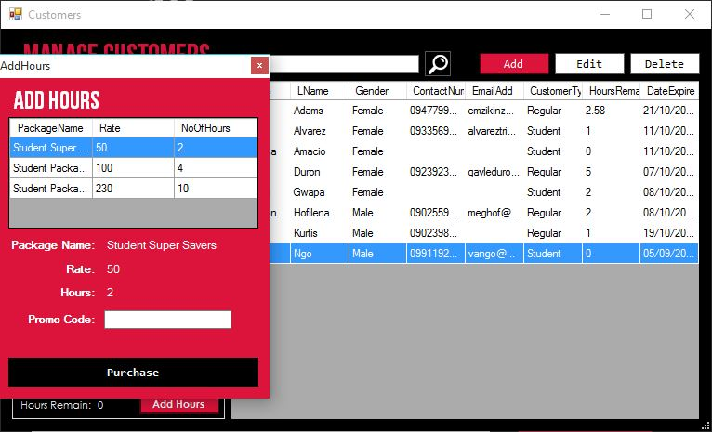

3.2 Manage Packages and Promos

The user may view all packages and promos offered by clicking the View button found under the packages and promos section in the main page. This window contains three tabs, each with a list of all packages or promos the user wishes to view. Daily, monthly and yearly reports of customer’s purchase of each package are also generated under this module.

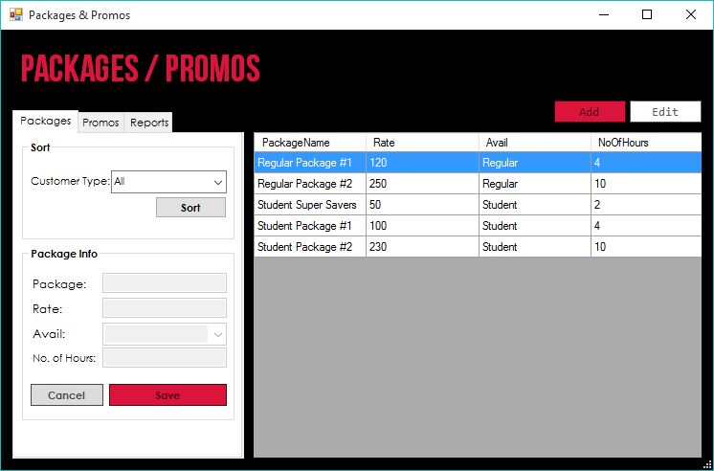

*Figure 1.* Packages Tab

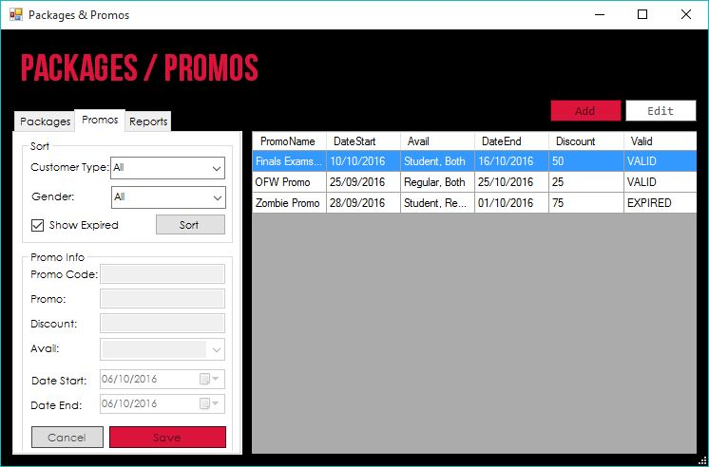

*Figure 2.* Promos Tab

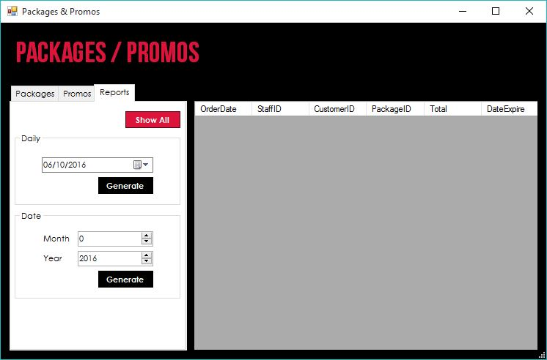

*Figure 3.* Reports Tab

For administrator-type users, new packages and promos can be added. User must fill up all required fields in order to record the new package or promo information.

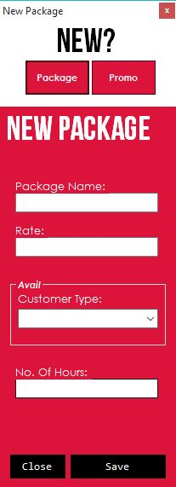 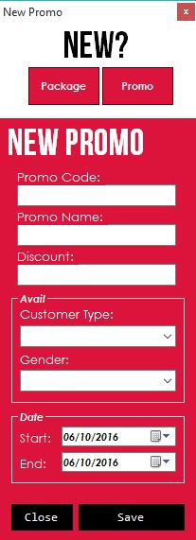

*Figure 1.* New Package or New Promo Button – selects from either a new package or a new promo to be made

*Figure 2.* Information Fields – contains the data input and information of the package or record being created

*Figure 3.* Save and Close Buttons – either saves the input to be recorded as a new package or promo, or cancels and discards all data input

3.3 Time In and Time Out Customers

When the user clicks the Time In button found in the main page, a new window is prompted. This window contains a list of customers the user may choose to time in. Once the user has selected a customer, they may click the Time In button to time the customer in. The user can time in multiple customers at a time.

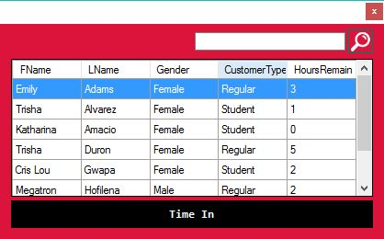

*Figure 1.* Search Bar – allows user to search through customers by first or last name

*Figure 2.* Table – contains list of customers a user may select to time in

*Figure 3.* Time In Button – the user clicks this to time in selected customer and submit the customer’s information as a new record in the logbook

A confirmation box is shown before timing in the customer. If the user wishes to proceed, the Yes button will be clicked. If not, the user stays on the window.

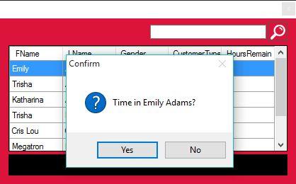

After the customer is timed in, a new record is added to the table in the main page. This shows the user all customers who are currently timed in and a countdown timer with their time remaining.

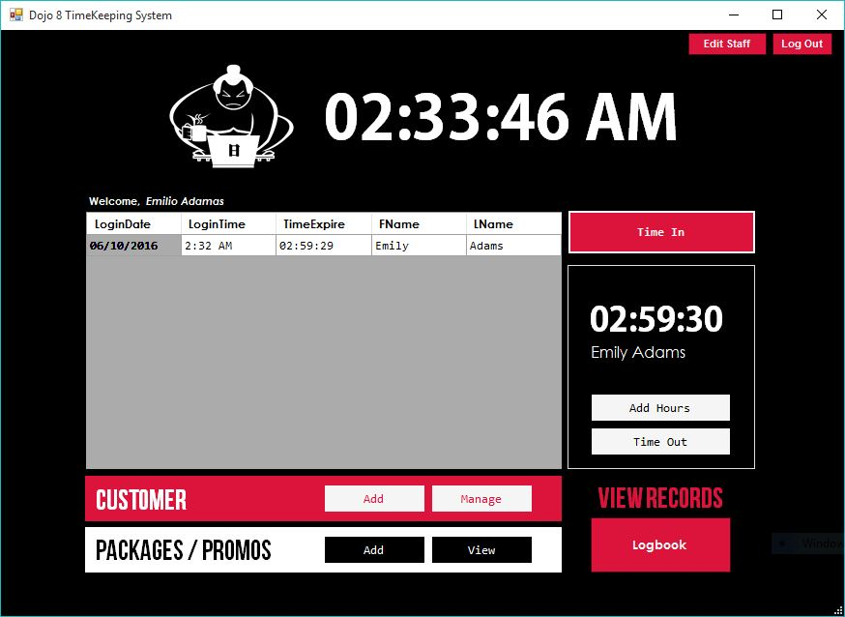

If a customer must time out, the user can select their name in the table and click the Time Out button. This prompts a confirmation box before timing out the user.

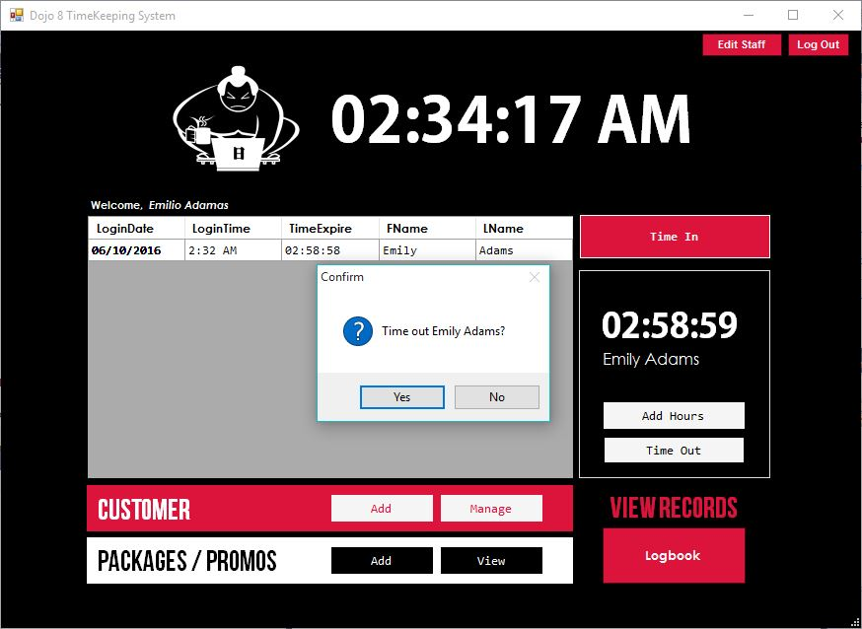

Once a user is timed out, their name is no longer shown on the table. This indicates that the user has successfully timed out and is no longer active. The logbook record is updated.

3.4 Generate Reports

The generate reports module can generate two kinds of reports: purchase reports of packages and the logbook reports. The purchase reports displays all customers who have bought a particular package. The logbook report simply displays all customers who have timed in and out of a particular date. These reports may be daily, monthly or yearly basis.

To generate purchase reports, the user may click the View button located in the Packages and Promos section in the main page. The user must then click the Reports button to display the reports page.

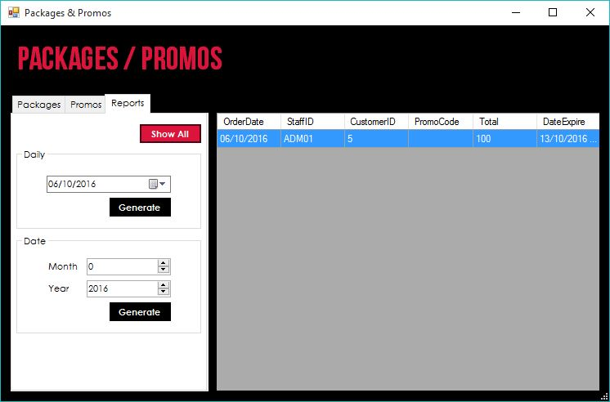

*Figure 1.* Table – displays a list of all reports

*Figure 2.* Show All Button – generates all purchase reports

*Figure 3.* Generate Buttons – generates reports with selected date filters

To generate logbook reports, the user may click the Logbook button in the main page. These logbook reports display all records of the customers that timed in on a given date. Hours spent and hours remain are then compute for each customer.

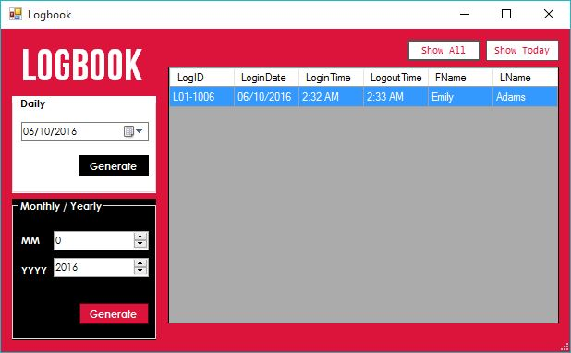

*Figure 1.* Table – displays a list of all customers who are logged

*Figure 2.* Show All Button – generates all logbook reports

*Figure 3.* Show Today Button – generates logbook reports of the current date

*Figure 3.* Generate Buttons – generates reports with selected date filters

3.5 Manage Staff

In order to manage staff, the user must be an administrator. Administrator privileges include management of staff and the adding and editing of packages and promos.

The manage staff button is enabled when only an administrator-type is logged in to the system. When Manage Staff button on the main page is clicked, it displays a new window where the user may add and edit staff.

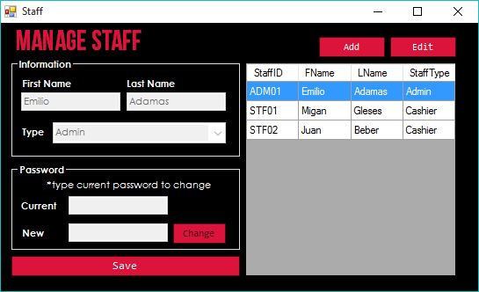

*Figure 1.* Table – displays a list of all staff members

*Figure 2.* Information fields – displays information of selected staff, may only be editable when user clicks Edit button

*Figure 3.* Add and Edit buttons – adds a new staff record or shifts user into edit mode

*Figure 4.* Password Change fields – where the user may change the current selected staff’s password

To add staff, the Add button must be clicked. A form then displays, where the users must input required fields and then submit these information as a new staff record.

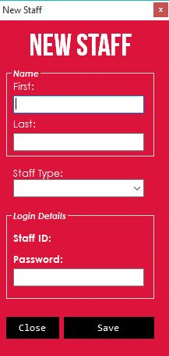

*Figure 1.* Information Fields – user must input first name, last name, and staff type

*Figure 2.* Staff ID – system will generate a staff ID for the new staff record

*Figure 3.* Password – user may input desired password for the new staff record

*Figure 4.* Close and Save Buttons – user may either close and discard the new staff or save, which adds the new staff as a new record